**Wg Cdr S S Iyengar, VSM**

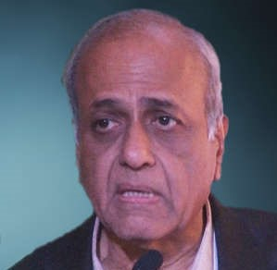

APPOINTMENT : Consultant Cardiologist and Academic Head, Manipal Hospital, Bangalore 560017

QUALIFICATIONS: MBBS, MD, DM (Cardiology) –AFMC, Pune

FRCP(E)

SPECIAL ACHIEVEMENTS: Clinical Tutor in Medicine, AFMC 1976-78

PUBLICATIONS: 68

AWARDS & FELICITATION: DGAFMS Silver Medal

VSM